**QR CODE BASED DESCRIPTION OF EXHIBITS**

**IN MUSEUMS**

**A MINI PROJECT REPORT**

***Submitted by***

**VISWANATHAN KRISHNAN 312321205189**

***in partial fulfilment for the award of the degree***

***of***

**BACHELOR OF TECHNOLOGY**

**IN**

**INFORMATION TECHNOLOGY**



**ST. JOSEPH’S COLLEGE OF ENGINEERING**

**(An Autonomous Institution)**

**St. Joseph’s Group of Institutions**

**OMR, Chennai 600119**

**ANNA UNIVERSITY : CHENNAI 600 025**

**April– 2024**

**ANNA UNIVERSITY :: CHENNAI 600 025**



**BONAFIDE CERTIFICATE**

Certified that this mini project report **“QR CODE BASED DESCRIPTION OF EXHIBITS IN MUSEUMS”** is the bonafide work of **VISWANATHAN KRISHNAN** **(312321205189)** who carried out the mini project under my supervision, for the partial fulfilment of the requirements for the award of the degree of Bachelor of Technology in Information Technology.

**SIGNATURE SIGNATURE**

**SUPERVISOR HEAD OF THE DEPARTMENT**

Dr. R. Elavarasan, M.E., (Ph.D).,Ms. G. Lathaselvi, M.E., (Ph.D).,

Assistant Professor, Associate Professor,

Department of Information Technology, Department of Information Technology,

St. Joseph’s College of Engineering, St. Joseph’s College of Engineering,

OMR, Chennai-600119. OMR, Chennai-600119.

**CERTIFICATE OF EVALUATION**

**College name :** St. Joseph’s College of Engineering

**Branch :** Information Technology

**Semester :** VI

|  |  |  |  |
| --- | --- | --- | --- |
| **SL.NO** | **NAME OF THE STUDENT** | **TITLE OF THE PROJECT** | **NAME OF THE SUPERVISOR WITH DESIGNATION** |
|  | VISWANATHAN KRISHNAN (312321205189) | QR CODE BASED DESCRIPTION OF EXHIBITS IN MUSEUM | Dr. R. Elavarasan, M.E., (Ph.D).,  Assistant Professor |

The report of the mini project work submitted by the above student in partial fulfilment for the award of Bachelor of Technology Degree in Information Technology of Anna University were evaluated and confirmed to be the report of the work done by the above student.

Submitted for the Mini Project and Viva Examination held on _______________.

**INTERNAL EXAMINER EXTERNAL EXAMINER**

**ACKNOWLEDGEMENT**

At the outset we like to express our sincere gratitude in thanking our beloved **Chairman**, **Dr. B. Babu Manoharan, M.A., M.B.A., Ph.D.,** for his constant guidance and support.

We would like to express our heartfelt thanks to our respected our **Managing Director** **Mr. B. Shashi Sekar, M.Sc.,** for his kind encouragement and blessings.

We would like to express our sincere thanks to our **Executive Director**, **Mrs. S. Jessie Priya, M.Com.,** for providing ample facilities in the institution.

We would like to extend our sincerest and most heartfelt gratitude to our beloved **Principal,** **Dr. Vaddi Seshagiri Rao, M.E., M.B.A., Ph.D., F.I.E.,** for his inspirational ideas during the course of the project.

We express our sincere thanks and gratitude to **Ms. G. Lathaselvi, M.E., (Ph.D.), Head of the Department,** Department of Information Technology, St. Joseph’s College of Engineering for her valuable guidance and assistance in solving the various intricacies involved in the project.

It is with a deep sense of gratitude that we acknowledge our indebtedness to our supervisor **Dr. R. Elavarasan, M.E., (Ph.D.),** for his expert guidance and connoisseur suggestion.

Last but not the least, we thank our family members and friends who have been the greatest source of support for successful completion of this mini project.

**TABLE OF CONTENTS**

|  |  |  |
| --- | --- | --- |
| **CHAPTER** | **TITLE** | **PAGE NO** |
|  | LIST OF FIGURES  LIST OF ABBREVIATIONS  ABSTRACT | vii  viii  ix |
| 1 | **INTRODUCTION**   * 1. QR CODE BASED DESCRIPTION   2. SYSTEM OVERVIEW   3. SCOPE OF THE PROJECT | 1  2 |
| 2 | **LITERATURE SURVEY** | 3 |
| 3 | **SYSTEM ANALYSIS**  3. 1. EXISTING SYSTEM  3.1.1. Disadvantages of Existing System  3. 2. PROPOSED SYSTEM  3.2.1. QR Code based Description  3.2.2. Accessibility Features  3.2.3 Feedback and Review System  3. 3. REQUIREMENTS SPECIFICATION  3.3.1 Hardware Requirements  3.3.2. Software Requirements  3. 4. LANGUAGE SPECIFICATION | 10  11  12  13  13 |
| 4  **CHAPTER** | **SYSTEM DESIGN**  4. 1. SYSTEM ARCHITECTURE  4.1.1. QR Code Generation  4.1.2. QR Code scanning and Decoding  4.1.3. Language Translation  **TABLE OF CONTENTS**  **TITLE**    4. 2. SOFTWARE DESIGN  4.2.1. Class diagram  4.2.2. Usecase diagram  4.2.3. Block diagrams | 14  15  16  **PAGE NO**  19  20  21 |
| 5 | **SYSTEM IMPLEMENTATION**  5.1. MODULES  5.1.1. QR Generation  5.1.2. QR Scanning and Decoding  5.1.3. Language Translation | 23  24  26 |
| 6 | **FUTURE ENHANCEMENTS**  **DISADVANTAGES OF PROPOSED SYSTEM** | 27  29 |
|  | **CONCLUSION**  **APPENDIX 1**  **APPENDIX 2**  **REFERENCES** | 30  31  39  43 |

**LIST OF FIGURES**

|  |  |  |
| --- | --- | --- |
| **FIGURE NO** | **TITLE** | **PAGE NO** |
| 4. 1. | ARCHITECTURE DIAGRAM FOR QR CODE GENERATION | 15 |
| 4. 2. | ARCHITECTURE DIAGRAM FOR QR CODE SCANNING | 16 |
| 4. 3. | ARCHITECTURE DIAGRAM FOR LANGUAGE TRANSLATION | 18 |
| 4. 4. | CLASS DIAGRAM | 19 |
| 4. 5. | USECASE DIAGRAM | 20 |
| 4. 6. | BLOCK DIAGRAM | 21 |
| 5. 1. | QR CODE STORAGE PATTERN | 25 |
| A2. 1. | ROLE SELECTION | 39 |
| A2. 2. | ADD EXHIBIT DETAILS | 39 |
| A2. 3. | UPDATE EXHIBIT DETAILS | 40 |
| A2. 4. | SCAN QR CODE | 40 |
| A2. 5. | DISPLAY DESCRIPTION | 41 |
| A2. 6. | LANGUAGE TRANSLATION | 41 |
| A2. 7. | STORING DATA IN DATABASE | 42 |

**LIST OF ABBREVIATIONS**

|  |  |
| --- | --- |
| **ABBREVIATION** | **DEFINITION** |
| ML | Machine Learning |
| NMT | Neural Machine Translation |
| API | Application Programming Interface |
| QR | Quick Response |
| OPAC | Online Public Access Catalog |
| BLEU | Bi-Lingual Evaluation Understudy |

**ABSTRACT**

In today's digital era, museums are embracing technology to enhance visitor engagement and education. Our project introduces a QR code-based guide that integrates digital storytelling with traditional museum experiences, enriching visitors' understanding of exhibits through a mobile application. By scanning QR codes placed next to artifacts, visitors can access detailed descriptions, historical insights, multimedia content, and interactive experiences.

Our system leverages QR code recognition technology for easy and accurate exhibit identification. The application design prioritizes seamless human-computer interaction, ensuring user-friendly navigation. It offers personalized exploration options, allowing users to delve into topics of interest, save favorite exhibits for later, and share their insights via feedback mechanisms.

This innovative guide not only makes cultural heritage more accessible and engaging but also ensures that museums remain relevant and intriguing for future generations. By integrating modern technology with cultural preservation, we aim to foster deeper connections between audiences and their heritage, stimulating curiosity and continuous learning.

In conclusion, our QR code-based guide represents a significant advancement in the realm of museum interpretation and visitor engagement. By seamlessly integrating technology into the museum experience, we aim to foster deeper connections between audiences and cultural heritage.

**CHAPTER 1**

**INTRODUCTION**

1. **1. QR CODE BASED DESCRIPTION**

In the dynamic digital landscape of today, museums are continually innovating to captivate visitors and provide immersive, educational experiences. As technology progresses, QR codes retain their significance as tools for enhancing access to information and enriching the museum-going journey. Through strategic integration, museums seamlessly blend physical and digital realms, crafting dynamic and interactive exhibitions that cater to diverse interests and learning styles. QR codes serve as gateways, unlocking supplementary content such as videos, audio guides, and interactive experiences, augmenting the visitor's understanding and engagement with artifacts. This fusion of tangible and digital elements empowers visitors to explore exhibits in depth, fostering curiosity and facilitating a deeper connection with cultural heritage.

By leveraging QR codes strategically, museums bridge the gap between past and present, tradition and innovation, offering a transformative journey that transcends physical boundaries and inspires a newfound appreciation for the rich tapestry of human history and creativity. This harmonious blend empowers visitors to delve deeper into exhibits, fostering interactive experiences that transcend traditional boundaries and ensuring a more enriching and fulfilling exploration of cultural heritage.

1. **2. SYSTEM OVERVIEW**

The QR code-based museum guide system simplifies visitor exploration by utilizing QR codes placed near exhibits. Visitors scan QR codes using a mobile application to access exhibit-related information and multimedia content. The system offers customizable experiences, and accessibility features. It also allows museums to provide language translation to view description in different languages. Overall, the system enhances visitor engagement and facilitates immersive experiences within the museum environment. This project involves

* Generating QR Code
* Scanning QR Code.
* Updating exhibit details.
* Translation of text description to other languages.
* Accessibility features like adjusting font size etc.

We have also used opensource API’s which include

* ImageBB API

Overall, the QR code-based museum guide system offers a comprehensive solution for enhancing visitor experiences, promoting learning and engagement, and facilitating meaningful interactions with museum exhibits and collections.

1. **3. SCOPE OF THE PROJECT**

This project involves the use of physical QR codes placed near exhibits, which visitors can scan using a smartphone or tablet equipped with a QR code scanning app. Upon scanning the QR code, users are directed to a webpage that provides information, multimedia content, and interactive experiences related to the exhibit.

These digital resources may include text descriptions, images, audio guides and other resources. In addition to this, this project also adds the functionality of language translation for people who don’t know the particular language in which the description is provided. They can convert it to their desired language and the content is translated to that particular language.

**CHAPTER 2**

**LITERATURE SURVEY**

**[1] Deepak Kumar Verma, Jitendra K Srivastava, Utkarsh Gupta, Divyansh Srivatsava, “QR Code Generator : A Security Perspective”, International Journal of Advanced Research in Computer and Communication Engineering, 2022.**

This paper introduces a methodology for generating QR codes through a web browser interface, facilitating easy creation of QR codes by users. The system utilizes a Drupal module integrated with the libqrencode C library to develop a user-friendly interface for encoding text into QR codes. Experiments conducted with single and multiple lines of text in English and Thai languages demonstrated successful and accurate QR code generation. QR codes have gained widespread adoption due to their ability to quickly connect consumers to online content via mobile phones, with mobile devices now being ubiquitous. Initially introduced by Denso Corporation in Japan in 1994 for inventory tracking in vehicle parts manufacturing, QR codes have evolved to serve various industries and purposes.

QR codes are standardized and capable of holding a significant amount of data, ranging from numeric to alphanumeric characters and Japanese Kanji/Kana symbols. They offer error correction capabilities, allowing data restoration even when parts of the code are distorted or damaged. The structure of a QR code consists of black and white patterns representing binary numbers, with finder patterns and encoding regions ensuring correct decoding and orientation.

The project's methodology involves utilizing Google's Chart Infographics API to generate QR codes based on user-provided text or URLs. Additionally, security measures are integrated to authenticate users, ensuring access to the QR code generation service only for registered individuals. The system workflow includes user registration, login, input of QR code parameters (size and text/URL), and generation of the QR code.

The paper concludes by highlighting the significance and increasing popularity of QR codes across various industries, including marketing, secure payment systems, advertising, and education. As technology continues to advance, QR codes are expected to find even wider applications in public domains, such as supermarkets and educational settings, as awareness and adoption increase. Overall, the paper underscores the simplicity and versatility of QR codes as a tool for digital connection and information dissemination.

**[2] Rohit Sahay, Mayur Waghela, Abhishek Mulgaonkar, Vansh Tiwari, “QR Code Generator using Python”, International Journal of Advanced Research in Computer and Communication Engineering, 2022.**

The paper explores the pervasive presence and utility of Quick Response (QR) codes in modern society, serving as a digital link between consumers and online content via mobile devices. It presents a methodology for QR code creation through a web browser interface, leveraging a Drupal module integrated with libqrencode C library. Experiments validated successful QR encoding of single and multiple lines of text in English and Thai languages. QR codes, initially introduced in 1994 by Denso Corporation for inventory tracking, have evolved into a versatile tool used across industries.

QR codes have gained widespread adoption due to their quick decoding and application in various contexts, including URL shortening services like Goo.gl and Bit.ly. Standardized and approved by AIM, JIS, and ISO, QR codes offer substantial data storage capacity, error correction capabilities, and 360-degree readability. The paper outlines the QR code structure, emphasizing finder patterns, separators, timing patterns, and alignment patterns, along with encoding regions and error correction mechanisms.

A step-by-step guide is provided for building a QR code generator in Python, highlighting module importation, main window creation, user input collection (text/URL, location, name, and size), and QR code generation and saving. The literature review discusses QR code authentication, security concerns, and attack vectors, emphasizing the need for user vigilance and verification of QR code origins.

Research findings underscore QR codes' versatility in encoding various types of information, including calendar events, geo-locations, Wi-Fi networks, and URLs. While QR codes offer advantages such as omnidirectional scanning, small size, and high data storage capacity, challenges include the need for QR code scanners and security risks like malicious QR code attacks.

The paper concludes with insights into the future scope of QR codes, particularly in cashless transactions and their increasing adoption in regions like South and East Asia. Potential enhancements include integrating QR code scanners into smartphone cameras and enabling two-way transactions. Despite scrutiny and the emergence of alternative technologies, QR codes are expected to remain relevant due to their ease of use and widespread acceptance.

In summary, the paper underscores the growing importance and versatility of QR codes in modern society, offering a convenient means of digital connectivity and information dissemination across various industries and applications.

**[3] Sunil Kunaragi, Suryakanth. Halburgi, U.A. Kaladagi, “Effective use of QR Code technology for library and information services”, Journal of Emerging Technologies and Innovative Research, 2021.**

The advancement of information technology has transformed the accessibility of information, liberating it from physical constraints. QR codes, enabled by mobile technology, exemplify this shift by providing instant access to information with a simple scan. The traditional reliance on complex web addresses has been supplanted by the convenience of QR codes, especially in places like libraries where users seek quick access to resources.

Libraries, recognizing the value of QR codes, are integrating them into various services to enhance user experience. QR codes facilitate quick access to library information, mobile learning resources, and various applications. They offer a seamless way to communicate and exchange knowledge, revolutionizing how information is stored and disseminated.

A QR code, or Quick Response code, is a 2-dimensional barcode capable of storing significant amounts of data. Originating in Japan in the 1990s, QR codes were initially used for tracking automobiles but have since found diverse applications, including library services.

The benefits of QR codes are manifold. They automate processes, provide quick access to content, and require no specialized skills to use. However, their misuse can lead to gimmickry and security risks, such as directing users to malicious URLs.

Generating QR codes requires basic hardware and software, including a computer, internet connection, and a QR code generator. Several websites offer free QR code generation services, allowing users to create codes for URLs, YouTube videos, PDF files, Google Maps locations, SMS messages, and email alerts.

At BLDE (DU) Central Library, QR codes are extensively utilized across various services. They are employed for library orientation, accessing e-books and databases, navigating institutional repositories, registering for workshops and seminars, locating books on shelves, gathering user feedback, promoting library exhibitions and new arrivals, and accessing the library's OPAC.

In conclusion, QR codes represent a significant technological advancement with wide-ranging applications in libraries and beyond. Their increasing popularity underscores their effectiveness in providing quick access to information and enhancing user experience in the digital age. With continued innovation, QR codes are poised to play an even greater role in facilitating information access for all.

**[4] Siyang Liu, Jian Guo, “Smart Museum and Visitor Satisfaction”, Journal of Autonomous Intelligence, 2023.**

The concept of smart museums, also known as intelligent spaces (iSpaces), represents a fusion of physical spaces with information and communication technology, enabling natural interactions between users and the environment. Smart museums leverage the Internet of Things (IoT) to transform artifacts into intelligent objects capable of autonomous decision-making, communication, and interaction with visitors. These innovative models enhance visitor experiences by providing customized services and improving the overall management and operation of museums.

Research in this field focuses on evaluating the intelligence of museums across various dimensions, including technology-enabled features, human-like interaction, adaptability, systematic efficiency, technological integration, and affordability. Factors such as usability, privacy, maintainability, input/output quality, real-time feedback, and compatibility are assessed to measure the intelligence level of museums.

A case study conducted at the Palace Museum in China, one of the most visited national museums, illustrates the practical application of these evaluation criteria. Data collected from visitor surveys and analyzed using factor analysis revealed three main dimensions of museum intelligence: usability, acceptability, and performance. These dimensions positively impact visitor satisfaction, indicating the importance of enhancing museum infrastructure and services to remain competitive and increase visitor engagement.

The study also identifies areas for future research, including validating the museum intelligence evaluation model, exploring the impact of intelligence on visitor behavior, and standardizing the evaluation system for smart museums. Overall, the development of evaluation methods for smart museums holds both theoretical and practical implications, offering opportunities for deeper understanding and improvement of cultural institutions and visitor experiences.

**[5] Aman Sharma, Vibhor Sharma, “Language Translation using Machine Learning”, International Research Journal of Modernization in Engineering Technology and Science, 2021.**

The paper discusses the application of Deep Neural Networks (DNNs) in machine translation, specifically focusing on the comparison between traditional statistical methods and neural network-based approaches, particularly Recurrent Neural Networks (RNNs). It begins with an introduction to machine translation and the limitations of earlier methods, leading to the adoption of neural translation (NMT) technology. The paper emphasizes the importance of in-depth learning methods, highlighting the role of RNNs, LSTMs, and other neural network architectures in improving translation accuracy.

The methodology section outlines the steps involved in building a machine translation pipeline using NMT, including data acquisition, cleaning, exploratory data analysis, and vectorization. The development of the model involves constructing an encoder-decoder architecture using RNNs and LSTM layers. The paper discusses the training process, evaluation of model performance, and challenges faced in natural language processing (NLP), emphasizing the need for more training data and sophisticated models to address these challenges.

Results indicate that the developed Seq2Seq model performs reasonably well, though there are areas for improvement, particularly in understanding context and nuances in translation. Despite these challenges, the paper concludes that advancements in deep learning have significantly enhanced translation quality, with Google reporting a 60% increase in accuracy with the transition to deep learning-based approaches in Google Translate. The conclusion underscores the importance of continued research and development in language translation to meet the growing demands for effective communication across different languages and cultures.

**[6] Lakshmi V. Reballiwar, Sakshi B. Yergude, Vaidyavi M. Urade, Sayli R. Birewar, Prof. Bhagyashree Karmarkar, “Language Translation using Machine Learning”, International Journal of Advanced Research in Science, Communication and Technology, 2023.**

The research paper explores the integration of machine learning (ML) techniques, such as neural machine translation (NMT) and recurrent neural networks (RNNs), into language translation applications to enhance accuracy and efficiency. It begins by assessing the current state of language translation applications, highlighting strengths and limitations. The paper emphasizes the development of ML models capable of context-aware translations to improve overall quality.

Training processes for ML-based translation applications are discussed, emphasizing the significance of large and diverse datasets. Transfer learning and fine-tuning techniques are explored to adapt pre-trained models to specific language pairs and domains, enhancing flexibility and applicability.

Evaluation of ML-based translation models involves comparative analyses against traditional approaches, utilizing metrics like BLEU score and user feedback to validate practical utility.

Advantages of ML-based translation applications include accuracy improvement, context understanding, real-time translation, customization, multilingual support, and continuous improvement. However, challenges such as data bias, complexity in some languages, lack of human nuance, resource intensity, security concerns, and dependency on training data quality are also noted.

In conclusion, while ML-powered translation applications offer significant advantages, including accuracy and real-time translation, they face challenges such as data bias and complexity in certain languages. Integrating ML with human expertise can lead to more effective and reliable translation solutions. Decision-makers should consider specific requirements and potential risks when opting for ML-powered translation applications, ensuring continuous improvements for optimal performance.

**[7] Bala Harshithaa B, “Language Translator App”, International Research Journal of Engineering and Technology, 2022.**

The paper proposes the development of an Android language translator application aimed at facilitating communication across language barriers. It emphasizes the need for efficient language translation solutions, particularly in scenarios where users are unfamiliar with the local dialect. The app aims to streamline the process of translation by offering features such as text and speech input, image scanning for text recognition, and offline functionality.

The literature survey outlines key insights gained from existing research in translation and language processing, providing guidance for the development process. Practical guides and scholarly articles have informed the design and functionality of the proposed application, ensuring its effectiveness in meeting user needs.

The problem statement highlights the challenges faced by individuals who encounter language barriers during communication. By offering real-time translation capabilities, particularly in offline mode, the proposed app aims to address these challenges and enhance user experience.

The methodology section describes the technical aspects of the application development process, including paragraph slicing techniques for text segmentation and the integration of Firebase ML Kit for machine learning capabilities. The use of Firebase ML Kit enables the implementation of features such as text recognition and translation, enhancing the app's functionality.

Overall, the paper presents a comprehensive approach to developing an Android language translator application, leveraging insights from existing literature and employing advanced technology to address the challenges of language barriers. Through its innovative features and offline functionality, the proposed application has the potential to significantly improve communication and facilitate seamless interaction across linguistic boundaries.

**CHAPTER 3**

**SYSTEM ANALYSIS**

1. **1. EXISTING SYSTEM**

The existing system in museums for describing exhibits typically involves static placards or signage placed near each exhibit, providing written descriptions of the artifact or artwork. Additionally, audio guides may be available for visitors to listen to narrated descriptions or historical context while viewing the exhibit. Some museums also offer guided tours led by docents or museum staff, providing in-depth information and interpretation of exhibits.

The proposed solution for describing exhibits using QR codes offers a more interactive and engaging experience for museum visitors. Each exhibit would be equipped with a QR code that visitors can scan using their smartphones or tablets. Upon scanning the QR code, visitors are directed to a webpage where they can access detailed information, multimedia content, and interactive experiences related to the exhibit.

1. **1. 1. Disadvantages of Existing System**

* Description provided on the placard is static and not updated once placed on the placard for a long period of time.
* The font size is too small such that it is unreadable for people with sight difficulty.
* Difficult for people with difficulty to read the content on the placard.

1. **2. PROPOSED SYSTEM**

The proposed system aims to revolutionize the way exhibits are described in museums by leveraging QR codes to provide visitors with dynamic and interactive experiences. Each exhibit will be equipped with a QR code that visitors can scan using their smartphones or tablets. Upon scanning, users will be directed to a dedicated webpage or mobile app where they can access a wealth of information, multimedia content, and interactive features related to the exhibit.

Key features of the proposed system include dynamic content delivery, offering visitors up-to-date and engaging content beyond traditional placards. Multimedia elements such as videos, images, audio guides, and virtual tours will enrich visitors' understanding and appreciation of the exhibit. Furthermore, the system will offer personalized experiences, allowing visitors to customize their exploration based on their interests and preferences.

Accessibility will be prioritized, with the inclusion of features such as text-to-speech functionality and adjustable font sizes to ensure inclusivity for all visitors.

Overall, the proposed system using QR codes offers a modern and versatile approach to describing exhibits, providing visitors with an enriching and interactive museum experience while catering to diverse interests and accessibility needs.

1. **2. 1. QR CODE BASED DESCRIPTION**

The proposed solution uses QR code to provide the description of the exhibit in the museum. Initially, the data of the exhibit is feeded into the software by the Admin and it generates a QR code which is placed near the exhibit. The workflow for QR code scanning and decoding begins with the user initiating the process within the museum guide app. Upon activation, the app accesses the device's camera functionality, enabling the user to scan the QR code displayed near an exhibit. The app captures an image of the QR code, which is then processed using image recognition algorithms to detect and decode the embedded information. This decoding process involves identifying the distinctive patterns and markers within the QR code image.

Once decoded, the app retrieves the encoded data, which typically includes details about the exhibit, such as its title, description, and relevant multimedia content. The app then presents this information to the user in a user-friendly format within the app interface. Users can interact with the displayed content, accessing additional resources, multimedia elements, or interactive features related to the exhibit.

Overall, this workflow ensures a seamless and efficient process for users to scan and decode QR codes, enabling them to access relevant information and enhance their museum exploration experience.

1. **2. 2. ACCESSIBILITY FEATURES**

Accessibility features are fundamental in ensuring that the QR code-based museum guide system is inclusive and accessible to all visitors, regardless of their abilities or disabilities. These features aim to accommodate diverse needs and promote equal access to museum resources. For users with visual impairments, text-to-speech (TTS) functionality provides a vital tool by converting written text into spoken words, allowing them to listen to exhibit descriptions, multimedia content. Adjustable font sizes cater to users with visual impairments or reading difficulties, enabling them to customize the text size within the app for improved readability and comprehension. Additionally, alternative content formats, such as audio descriptions, ensure that visitors with disabilities can access exhibit information through non-visual means. By incorporating these accessibility features, the QR code-based museum guide system can create a more inclusive and welcoming environment, ensuring that all visitors can fully participate in and enjoy their museum experience.

1. **2. 3. FEEDBACK AND REVIEW SYSTEM**

The feedback and review system in the QR code-based museum guide plays a crucial role in improving visitor experiences and enhancing the overall effectiveness of the system. After exploring exhibits and accessing content through QR codes, users are prompted to provide feedback on their experience. This feedback may include ratings, comments, or suggestions for improvement. Additionally, users can leave reviews for specific exhibits, highlighting aspects they enjoyed or areas they felt could be enhanced.

The system aggregates and analyzes user feedback and reviews to identify trends, areas of improvement, and opportunities for enhancement. Museum administrators and curators can then utilize this data to make informed decisions about content updates, exhibit placement, and system enhancements. Furthermore, the feedback and review system fosters a sense of community engagement, empowering visitors to contribute to the ongoing improvement of the museum experience. By facilitating open communication and dialogue between visitors and museum staff, the feedback and review system plays a vital role in ensuring that the QR code-based museum guide continues to meet the needs and expectations of its users.

The user feedback is analysed using the Natural Language Processing techniques and the review is classified as positive, negative or neutral. Using this, both the users and museum can classify the reviews and suggestions received as per their needs.

Natural language Processing (NLP) is used to make computers understand the human language and even respond in the same way. It consists of understanding, analysing, manipulating and interpreting human language.

1. **3. REQUIREMENTS SPECIFICATION**
2. **3. 1. Hardware Requirements**

* QR Code Labels
* Smartphones or Tablets
* Internet Connectivity
* Audio Output Devices

1. **3. 2. Software Requirements**

* Database Management System
* API keys
* QR Code Generation and Decoding using Python

1. **4. LANGUAGE SPECIFICATION**

The QR code-based museum exhibit system utilizes Python, primarily with the Flask framework for backend development. MySQL is chosen for data storage. Frontend development employs HTML5, CSS3, JavaScript, and React.js for dynamic web interfaces. QR code generation utilizes the Qrcode library for generating QR codes and the Qreader library for decoding them in Python. This setup ensures efficient backend processing, flexible data management with MySQL, and interactive frontend experiences with React.js. Additionally, the use of specific Python libraries facilitates seamless QR code generation and decoding within the system.

Some of the important packages imported include:

* Qrcode
* QReader
* Flask
* PIL
* JSON
* Axios
* MySQL
* Googletrans

The integration of Googletrans, a Python library, enhances the language translation capabilities of the QR code-based museum exhibit system. This library taps into Google's Translation API, allowing seamless translation of exhibit descriptions or other textual content within the system. By leveraging Googletrans, users can access translations for various languages, enhancing accessibility and understanding for a diverse audience. This feature enriches the user experience by providing multilingual support, making exhibit information more accessible to visitors from different linguistic backgrounds.

**CHAPTER 4**

**SYSTEM DESIGN**

1. **1. SYSTEM ARCHITECTURE**
2. **1. 1. QR CODE GENERATION**

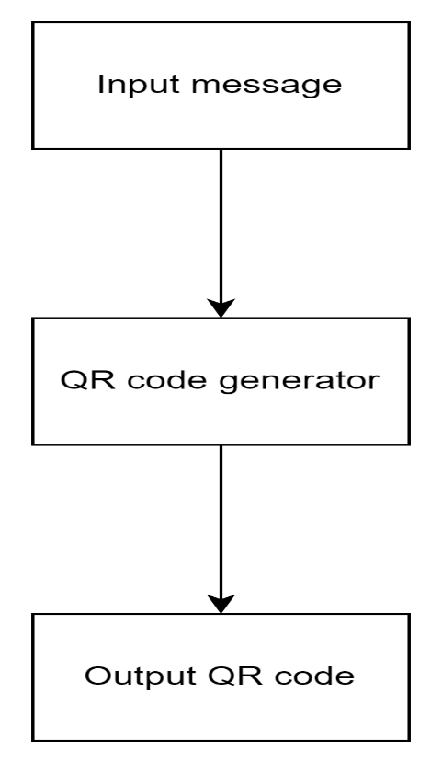

**Fig 4.1 Architecture diagram for QR code generation**

**User Interface (UI):**

Enables user interaction for initiating QR code generation and provides feedback on the process.

**QR Code Generation Module:**

Interfaces with the backend server to retrieve exhibit details.

Utilizes library – Qrcode to encode exhibit information into QR codes.

**Backend Server:**

Provides the necessary exhibit details to the QR code generation module.

Interfaces with the database to retrieve exhibit information.

**Database:**

Stores exhibit details required for QR code generation.

This architecture ensures efficient QR code generation, facilitating the seamless integration of exhibit information into QR codes for museum visitors.

1. **1. 2. QR CODE SCANNING AND DECODING**

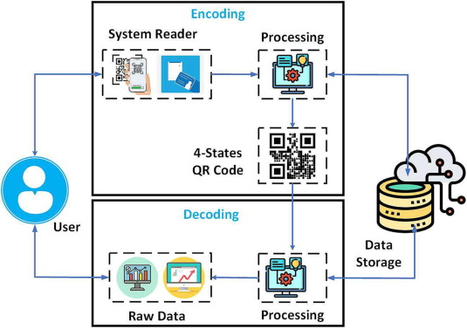

**Fig 4.2. Architecture Diagram for QR code scanning**

**User Interface (UI):**

Facilitates user interaction to initiate QR code scanning and provides feedback on the process.

**QR Code Scanning Module:**

Interfaces with the device camera to capture QR code images.

Utilizes libraries like Qreader to decode the embedded data within the QR codes.

**Processing Module:**

Receives the decoded information from the scanning module.

Orchestrates further actions, such as querying a database for associated exhibit details.

**Backend Server:**

Provides support for processing module activities and accesses the database for exhibit information.

**Database:**

Stores exhibit details associated with QR codes for retrieval during scanning.

This architecture ensures efficient QR code scanning and decoding processes, enabling seamless retrieval of exhibit information within the app for museum visitors.

1. **1. 3. LANGUAGE TRANSLATION**

**User Interface (UI):**

Allows users to trigger language translation requests and provides feedback on the process.

**Translation Module:**

Interfaces with external language translation services like Googletrans.

Processes text inputs and invokes the translation service for real-time translation.

**External Language Translation Service:**

Provides language translation functionality, processing text inputs and returning translated outputs.

**Processing Module:**

Receives translated text from the translation module. Integrates the translated content back into the user interface for display.

This architecture facilitates effective language translation within the app, enhancing accessibility for users with diverse linguistic backgrounds.

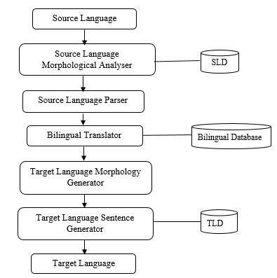

**Fig 4. 3. Architecture diagram for Language Translation**

The architecture diagram for language translation involves integrating a user interface element to trigger translation requests and display feedback. A translation module interfaces with external services, like Googletrans, for real-time language translation. Upon receiving text inputs, the module invokes the translation service, which processes the text and returns the translated output. This translated content is then seamlessly integrated back into the user interface for display. This architecture ensures effective language translation capabilities within the app, enhancing accessibility for users with different linguistic backgrounds. By modularizing translation functionalities and leveraging external services, the system optimizes performance and scalability, facilitating smooth communication across languages and enriching the user experience.

1. **2. SOFTWARE DESIGN**

Software design is a process of problem-solving and planning for a software solution. After the purpose and specifications of software is determined, software developers will design or employ designers to develop a plan for a solution. It includes construction component and algorithm implementation issues which shown in as the architectural view. During this chapter we will introduce some principles that are considered through the software design.

1. **2. 1. CLASS DIAGRAM**

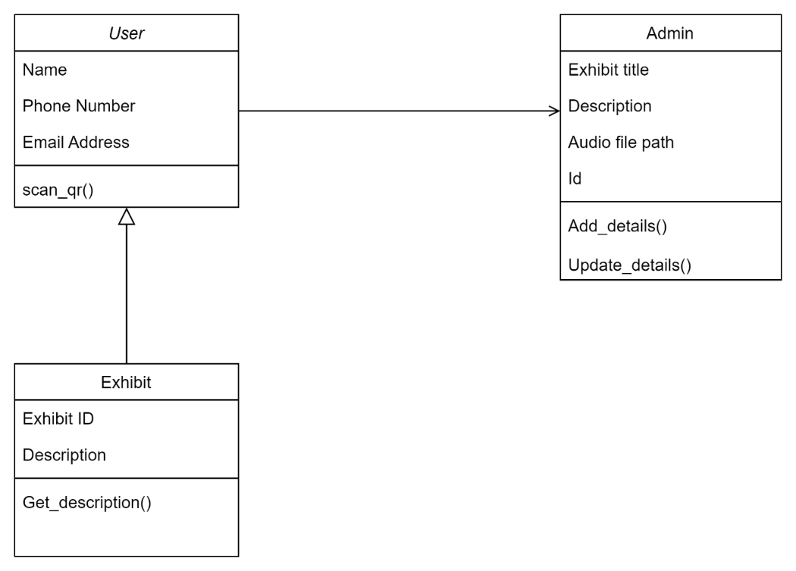

**Fig 4. 4. Class diagram**

Class diagrams serve as visual representations to depict generic descriptions of potential systems. They, along with collaboration diagrams, offer alternate views of object models. While class diagrams primarily feature classes, object diagrams showcase objects. However, when handling diverse metadata, a fusion of classes and objects can occur, blurring the strict division between them. This adaptability enables comprehensive odelling of systems, accommodating various complexities and intricacies within the software architecture.

**4. 2. 2. USECASE DIAGRAM**

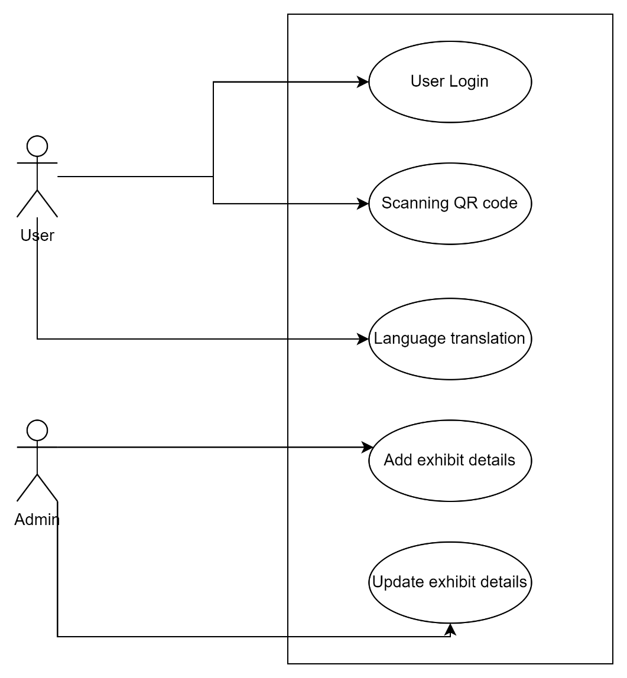

**Fig 4. 5. Usecase diagram**

The Use Case Diagram for the museum exhibit app includes "Scan QR Code" and "Request Translation" as primary use cases. "Scan QR Code" involves the user scanning QR codes to access exhibit information, while "Request Translation" allows users to request language translation of exhibit details. Both use cases interact with the "User Interface" and "Backend Server" components. Additionally, "Request Translation" may involve interactions with external translation services. These use cases aim to enhance user engagement and accessibility within the app by providing seamless access to exhibit information and language translation capabilities.

**4. 3. BLOCK DIAGRAM**

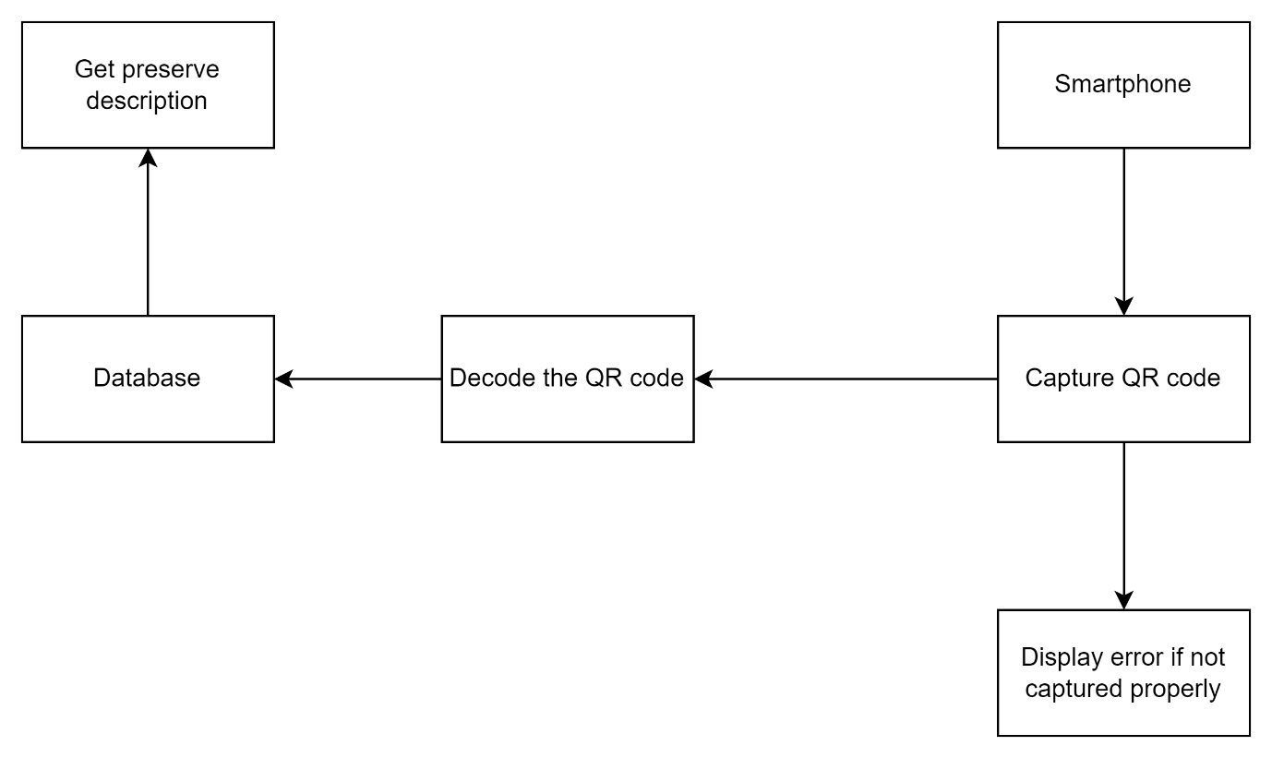

**Fig 4. 6. Block diagram**

The primary objective of the application is to digitize the process of accessing descriptions of preserves in museums. Upon logging in, users are directed to the homepage, where they can easily scan QR codes to retrieve exhibit details. Once a QR code is captured, the image is transmitted to the backend server for processing. Subsequently, the description associated with the QR code is displayed on the output page, enabling users to access pertinent information seamlessly.

For users seeking translation of the descriptions, a translate button is provided. Clicking on this button triggers a popup window, prompting users to select their desired language. After selecting the language, users submit their choice, leading to the translation of the page's content based on the selected language. This feature enhances accessibility for users with diverse linguistic backgrounds, ensuring that exhibit descriptions are comprehensible to a wider audience.

From the museum's perspective, officials have administrative privileges to manage the contents associated with QR codes. They can add, delete, or update exhibit details, ensuring that the information presented to visitors remains relevant and up-to-date. This administrative functionality empowers museums to curate their exhibits effectively and provide enriching experiences for visitors. Overall, the application serves as a digital platform that streamlines the process of accessing and managing exhibit descriptions, fostering greater engagement and accessibility within museum settings.

**CHAPTER 5**

**SYSTEM IMPLEMENTATION**

1. **1. SYSTEM MODULES**

This system consists of 3 major modules which enhance the user experience. They are as follows :

* QR Generation
* QR Scanning
* Language Translation

**5. 1. 1. QR Generation**

The QR Code Generation Module is a pivotal component of the museum exhibit app, responsible for dynamically creating QR codes that encode exhibit-specific information. Its primary function is to interface with the backend server to retrieve exhibit details and encode them into QR codes using libraries like Qrcode. This module ensures the seamless generation of QR codes that encapsulate pertinent exhibit information, such as descriptions, images, and multimedia content.

This module operates in tandem with the backend server, which provides the necessary exhibit details required for QR code generation. Upon receiving exhibit information, the module employs the Qrcode library or similar tools to encode the data into QR codes, which can then be displayed or distributed to users within the app.

Key features of this module include its ability to dynamically generate QR codes on-demand, its integration with the backend server for exhibit data retrieval, and its support for various data types within the QR codes. Additionally, scalability and performance optimizations ensure efficient QR code generation, even under high demand.

QR code generation can be implemented using the below given base code:

import qrcode

def generate_qr():

try:

data = {“Name”: “Enter Name here”, “Description”: “Enter Description here”, “audio_file”: “Enter audio file name here”}

# Generate QR code

qr = qrcode.QRCode(version=1,

error_correction=qrcode.constants.ERROR_CORRECT_L,

box_size=3, border=4

)

qr.add_data(data)

qr.make(fit=True)

# Create an image from the QR Code instance

img = qr.make_image(fill_color="black", back_color="white")

# Save the image

img.save("qrcode.png")

return "Exhibit details Added"

except:

return "Error adding details"

**5. 1. 2. QR SCANNING AND DECODING**

The QR Code Scanning and Decoding Module is a critical element of the museum exhibit app, designed to facilitate the seamless retrieval of exhibit information through QR code scanning. Its primary function involves capturing QR code images in real-time using the device camera and decoding the embedded data within the codes.

This module interfaces directly with the device camera API, enabling users to scan QR codes efficiently and accurately within the app. Leveraging libraries like Qreader or similar tools, it employs advanced decoding algorithms to reliably extract information encoded within QR codes.

Upon successful decoding, the module passes the extracted data to the processing module for further actions, such as querying the database for associated exhibit details. Key features of this module include its real-time scanning capabilities, robust decoding algorithms, and seamless integration with other app components.

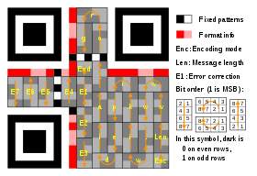

**Fig 5.1 QR code storage pattern**

QR code decoding can be implemented using the below given base code:

from qreader import QReader

import cv2, json

def decode_text(Image):

# Create a QReader instance

qreader = QReader()

# Get the image that contains the QR code

image = cv2.cvtColor(cv2.imread(Image), cv2.COLOR_BGR2RGB)

# Use the detect_and_decode function to get the decoded QR data

decoded_text = qreader.detect_and_decode(image=image)

response_string = decoded_text[0].replace( "'",'"')

response = json.loads(response_string)

return response

**5. 1. 3. LANGUAGE TRANSLATION**

The Language Translation Module plays a pivotal role in facilitating multilingual accessibility within the museum exhibit app by enabling real-time language translation of exhibit descriptions and other textual content. Its primary objective is to seamlessly integrate with external language translation services, such as Googletrans, to provide accurate and efficient translations across various languages.

This module interfaces with the user interface, allowing users to trigger translation requests and receive translated content. Upon receiving text inputs, it invokes the chosen translation service, which processes the text and returns the translated output in the desired language.

Key features of this module include its ability to support real-time translation requests, integration with external translation services for reliable language translation capabilities, and seamless integration with the user interface for a smooth user experience.

Language translation can be implemented using the below given base code :

from googletrans import Translator

def translate_content(text_to_translate):

#Initialize the translator

translator = Translator()

translated_text = translator.translate(text_to_translate, dest="en")

translated = translated_text.text

return translated

**CHAPTER 6**

**FUTURE ENHANCEMENTS**

Future enhancements for the museum exhibit app project are aimed at elevating user experience, enriching functionality, and ensuring inclusivity. One significant avenue for advancement involves integrating augmented reality (AR) features to offer immersive interactions with exhibits. AR technology could enable users to visualize historical artifacts in 3D, overlay additional contextual information onto exhibits, or even recreate historical scenes for deeper engagement and understanding.

Furthermore, personalized recommendation systems could be implemented to tailor exhibit suggestions based on user preferences and behavior. By analyzing user interactions and past viewing history, machine learning algorithms could dynamically recommend exhibits that align with individual interests, fostering greater engagement and satisfaction among visitors.

Enhancements in accessibility features are also critical for ensuring inclusivity. Integrating audio descriptions, tactile guides, or sign language interpretation options can accommodate visitors with visual or hearing impairments, providing equal access to exhibit content and enhancing overall accessibility.

Moreover, the integration of interactive multimedia elements such as videos, interactive touchscreens, or immersive soundscapes could offer diverse modes of engagement and learning opportunities for visitors. These elements could provide additional context, storytelling, or interactive experiences to enhance understanding and engagement with exhibits.

Data analytics and visitor tracking technologies offer valuable insights into visitor demographics, exhibit popularity, and engagement metrics. Leveraging this data-driven approach can inform decisions regarding exhibit curation, layout optimization, and future enhancements to the app, ensuring that the app evolves in line with visitor preferences and expectations.

Continuous refinement of the app's performance, security, and scalability is essential for maintaining smooth operation and user satisfaction. Regular updates to incorporate the latest technological advancements, address user feedback, and ensure compliance with security standards will help keep the app relevant and competitive in the dynamic landscape of museum experiences. Overall, these future enhancements aim to create a more immersive, inclusive, and engaging experience for visitors, fostering a deeper appreciation and understanding of museum exhibits.

**DISADVANTAGES OF PROPOSED SYSTEM**

While the proposed system for digitizing exhibit descriptions in museums offers numerous advantages, it also comes with potential disadvantages that warrant consideration.

Firstly, the system's heavy reliance on technology introduces a vulnerability to technical issues and downtimes. Any disruptions in QR code scanning, backend processing, or language translation services could impede users' ability to access exhibit descriptions, leading to frustration and dissatisfaction.

Moreover, while the digital approach enhances accessibility for many visitors, it may inadvertently exclude those with limited access to smartphones or internet connectivity. Elderly visitors or individuals from underserved communities may struggle to navigate the system, limiting their ability to fully engage with the museum exhibits.

Furthermore, automated language translation services, while convenient, may not always accurately convey the nuances and cultural context of exhibit descriptions. This can lead to misunderstandings or misinterpretations, particularly for exhibits with complex or culturally specific content, potentially diminishing the overall educational value of the museum experience.

From a security standpoint, storing user data such as login credentials and translation preferences poses privacy risks if not adequately protected. Without robust security measures, sensitive information could be vulnerable to unauthorized access or cyber-attacks, compromising user privacy and trust in the system.

Additionally, maintaining and updating the system requires ongoing effort and resources. Museum officials must continuously review and update exhibit descriptions, QR code contents, and translation options to ensure accuracy and relevance. This ongoing maintenance incurs costs related to technology infrastructure, software development, and staff training, which may strain the resources of smaller museums or institutions with limited budgets.

In summary, while the proposed system offers significant benefits in terms of accessibility and user experience, addressing these potential disadvantages through careful planning, robust security measures, and ongoing maintenance is crucial to ensuring its effectiveness and inclusivity for all museum visitors.

**CONCLUSION**

In conclusion, the museum exhibit app represents a significant advancement in the realm of digital engagement with cultural heritage. By leveraging technologies such as QR code scanning, language translation, and augmented reality, the app offers visitors a dynamic and immersive experience, transcending traditional museum interactions. Through seamless integration of these features, users can explore exhibits with greater depth and accessibility, whether through real-time language translation, interactive multimedia elements, or personalized exhibit recommendations.

Moving forward, the project holds immense potential for further innovation and enhancement. Future iterations could focus on refining existing features, such as improving translation accuracy or expanding AR capabilities, while also exploring new avenues for engagement, such as integrating virtual reality experiences or incorporating gamification elements. Additionally, ongoing efforts to optimize performance, security, and accessibility will ensure the app remains user-friendly and inclusive for diverse audiences.

Overall, the museum exhibit app represents a transformative tool for cultural institutions, empowering them to connect with visitors in innovative ways and foster deeper appreciation and understanding of their collections. By embracing technological advancements and user-centric design principles, the project sets a precedent for the future of digital museum experiences.

**APPENDIX 1**

**CODE SNIPPETS**

**app.py**

from flask import Flask, request

from decode import decode_text

from generate import generate_qr

from translate import translate_content

from fetchupdate import fetch_details, update_details

from flask_cors import CORS

import base64, cv2

import numpy as np

import mysql.connector as sql_con

app = Flask(__name__)

cors = CORS(app)

@app.route("/")

def home():

return "Access Denied - 404"

@app.route("/addexhibit", methods=["POST"])

def add_exhibit():

title = request.form["title"]

desc = request.form["description"]

image_exh = request.form["image_exh"]

val = generate_qr(title, desc, image_exh)

return val

@app.route("/getdesc", methods=["POST"])

def get_desc():

image_data = request.form["image_cap"]

if ',' in image_data:

header, image_data = image_data.split(',', 1)

image_bytes = base64.b64decode(image_data)

image_array = np.frombuffer(image_bytes, dtype=np.uint8)

image = cv2.imdecode(image_array, cv2.IMREAD_COLOR)

res = decode_text(image)

res = fetch_details(res)

return res

@app.route("/translatetext", methods=["POST"])

def translate_text():

desc = request.form["content"]

lang = request.form["language"]

res1 = translate_content(desc, lang)

return res1

@app.route("/fetch", methods=["POST"])

def fetch_det():

id = request.form["id"]

res2 = fetch_details(id)

return res2

@app.route("/update", methods=["POST"])

def update_det():

id = request.form["id"]

title = request.form["title"]

desc = request.form["description"]

image_exh = request.form["image"]

res3 = update_details(id, title, desc, image_exh)

return res3

if __name__=="__main__":

app.run(debug = True)

**get_desc.js**

import "./get_desc.css";

import React, { useState } from "react";

import Webcam from "react-webcam";

import { FaCamera } from "react-icons/fa";

import { useNavigate } from "react-router-dom";

import axios from "axios";

function Get_desc() {

const [image, setImage] = useState(null);

const webcamRef = React.useRef(null);

const navigate = useNavigate();

const capture = React.useCallback(() => {

const imageSrc = webcamRef.current.getScreenshot();

setImage(imageSrc);

const formData = new FormData();

formData.append('image_cap', imageSrc);

axios.post('http://127.0.0.1:5000/getdesc', formData, {

headers: {

'Content-Type': 'multipart/form-data'

}

})

.then(response => {

console.log(response.data);

navigate('/show', { state: { data: response.data } });

})

.catch(error => {alert('Please rescan your QR code'); console.log(error); window.location.reload();});

}, [webcamRef]);

return (

<div className="main1">

<h2 className="title1">Scan QR Code Here</h2>

{image ? (

<div>

<img src={image} alt="Captured" />

</div>

) : (

<div>

<Webcam

audio={false}

ref={webcamRef}

screenshotFormat="image/jpeg"

style={{ width: "90%", height: "auto" }}

className="camera"

/>

<button onClick={capture} className="capture_btn"><FaCamera/></button>

</div>

)}

</div>

);

}

export default Get_desc;

**add_desc.js :**

import "./add_desc.css";

import React, { useState } from "react";

import axios from "axios";

function Add_desc() {

const [file, setFile] = useState(null);

const [title, setTitle] = useState('');

const [description, setDescription] = useState('');

const handleFileChange = (event) => {

const selectedFile = event.target.files[0];

if (selectedFile) {

const reader = new FileReader();

reader.onload = (e) => {

setFile(e.target.result);

};

reader.readAsDataURL(selectedFile);

} else {

console.log('No file selected');

}

};

const handleSubmit = (() => {

const formData = new FormData();

formData.append("image_exh", file);

formData.append('title', title);

formData.append('description', description);

axios.post("http://127.0.0.1:5000/addexhibit", formData, {

headers: {

'Content-Type': 'multipart/form-data'

}

})

.then(response => {

alert(response.data);

})

.catch(error => {

alert('Upload failed: ' + error.message);

});

});

return (

<div className="main3">

<h2 className="title3">Add Exhibit Details</h2>

<p className="label3">Title</p>

<input type="text" className="input3" value={title} onChange={e => setTitle(e.target.value)}></input>

<p className="label3">Description</p>

<textarea type="text" className="input3" value={description} onChange={e => setDescription(e.target.value)} rows="4"></textarea>

<p className="label3">Select Image</p>

<input

type="file"

accept="image/*"

name="image_exh"

onChange={handleFileChange}

></input>

{file && <img src={file} alt="Preview" className="preview-img" />}

<button className="sub_btn" onClick={handleSubmit}>Submit</button>

</div>

);

}

export default Add_desc;

**APPENDIX 2**

**SCREENSHOTS**

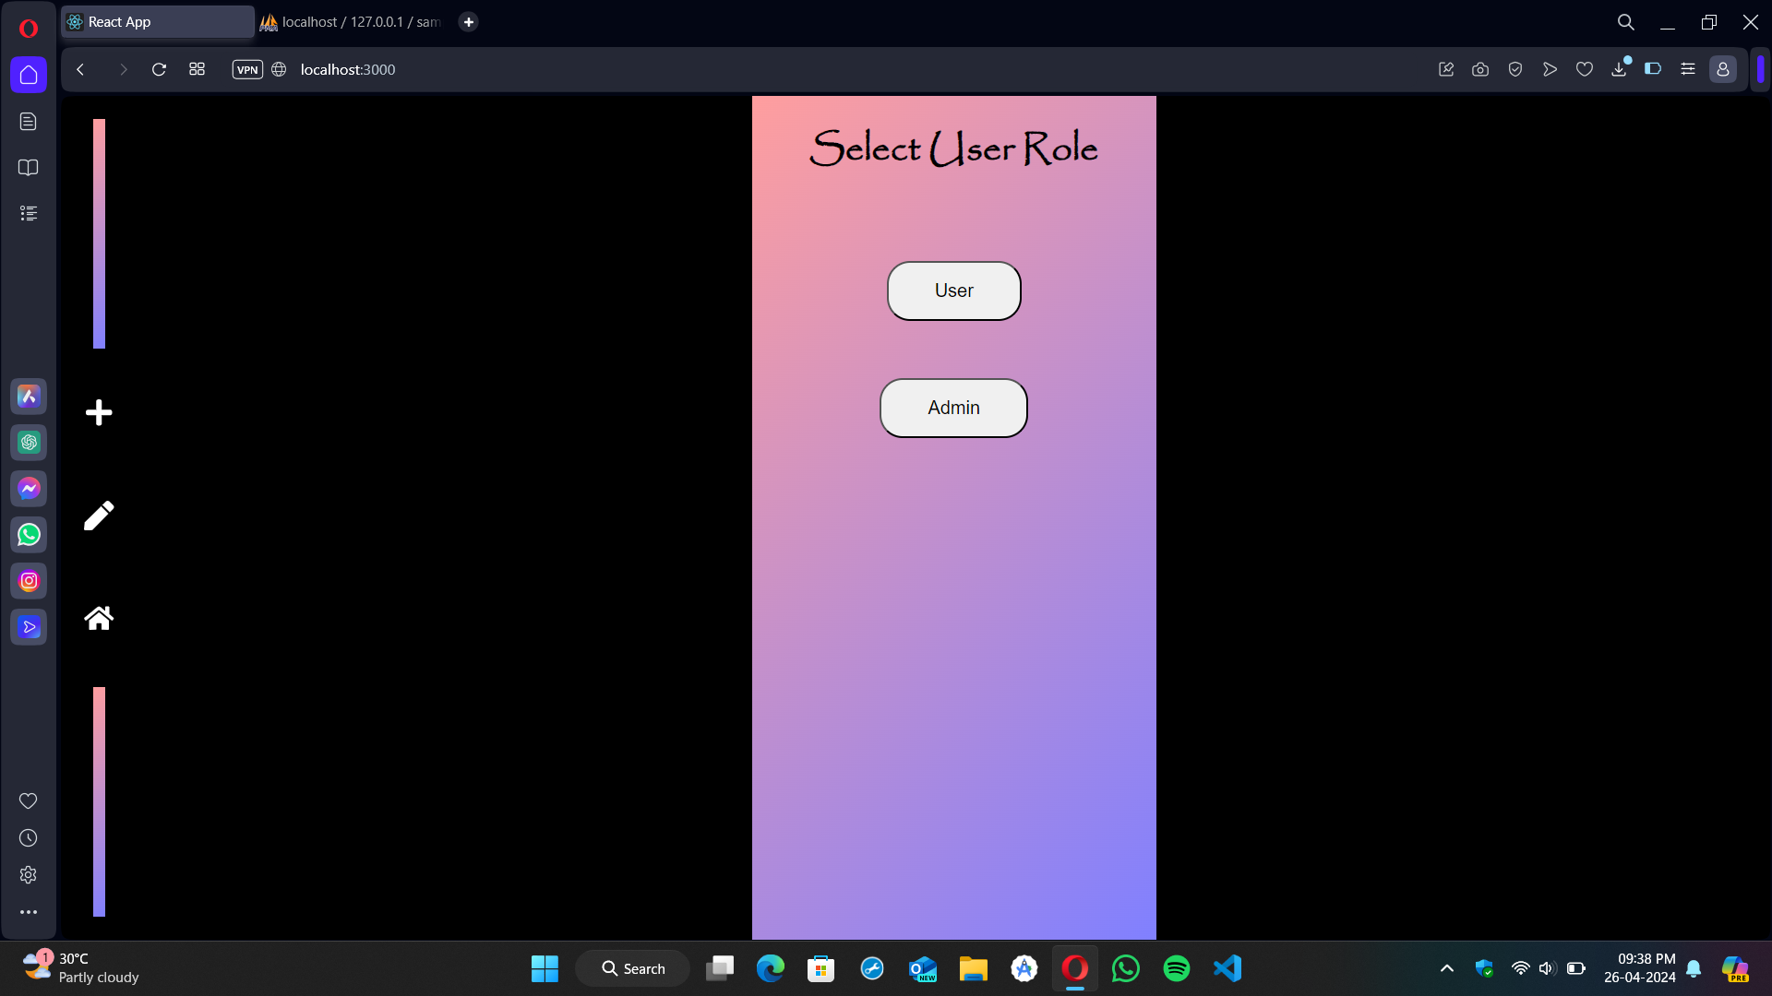

**Fig A2. 1. Role selection**

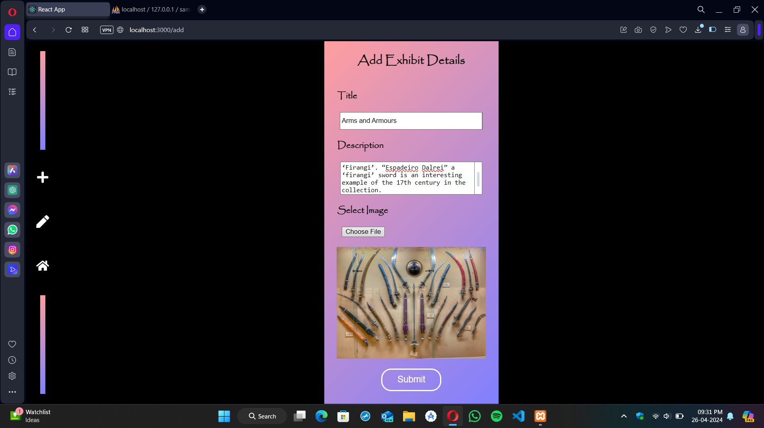

**Fig A2. 2. Adding exhibit details**

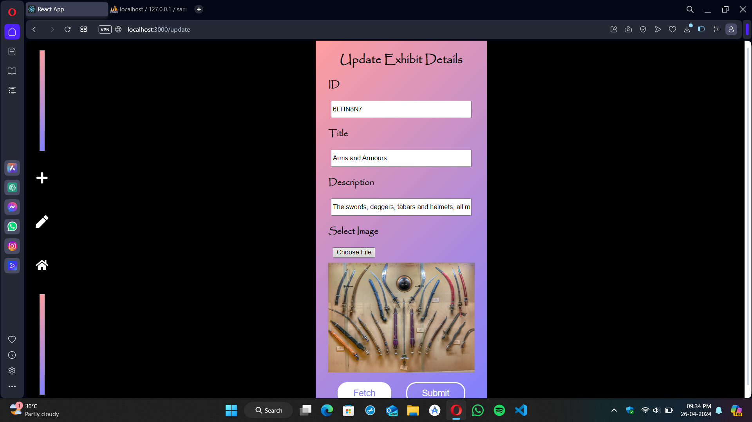

**Fig A2. 3. Update Exhibit details**

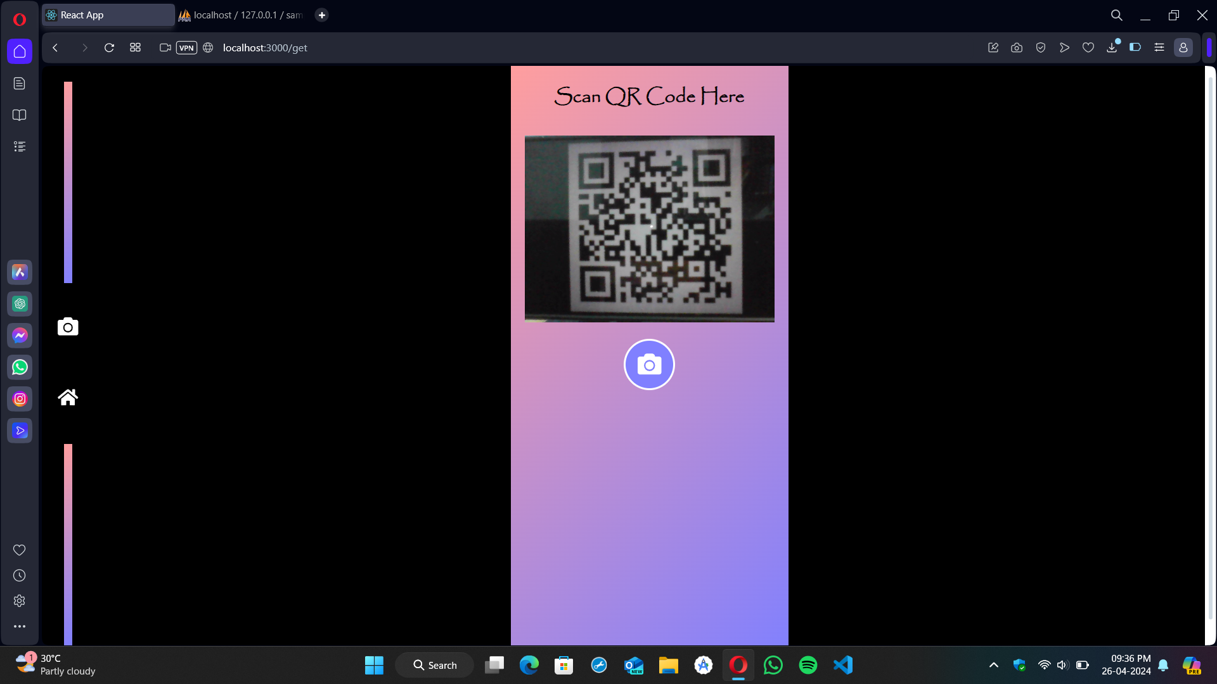

**Fig A2. 4. Scan QR code**

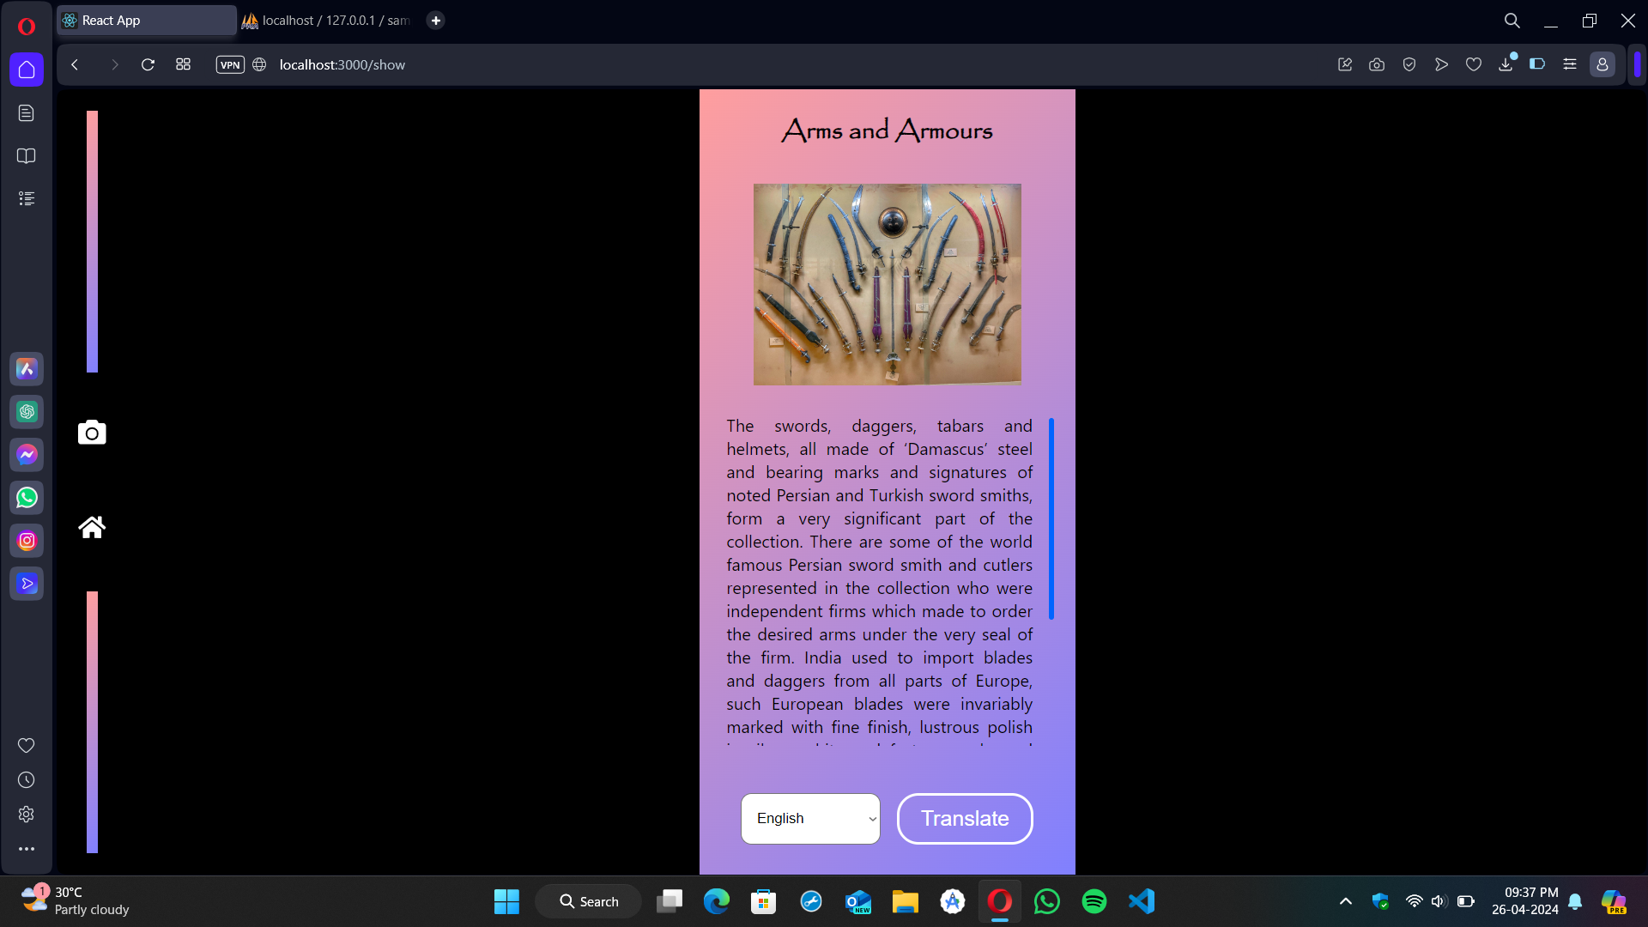

**Fig A2. 5. Display description**

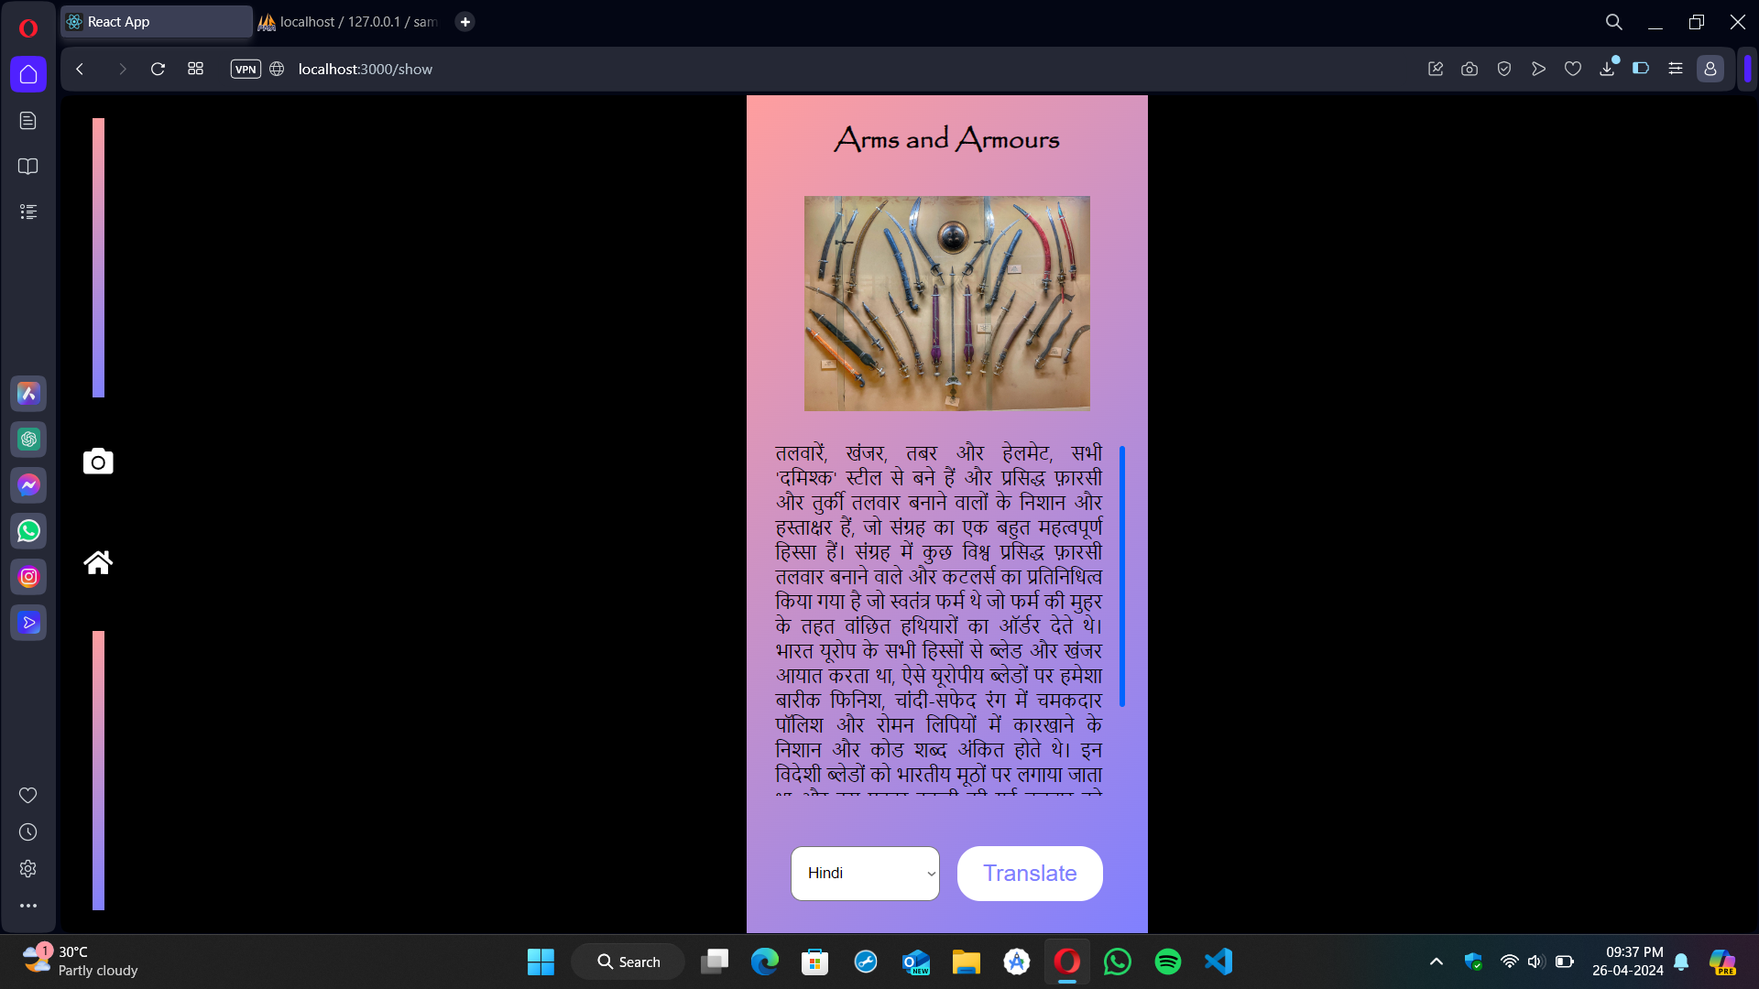

**Fig A2. 6. Language Translation**

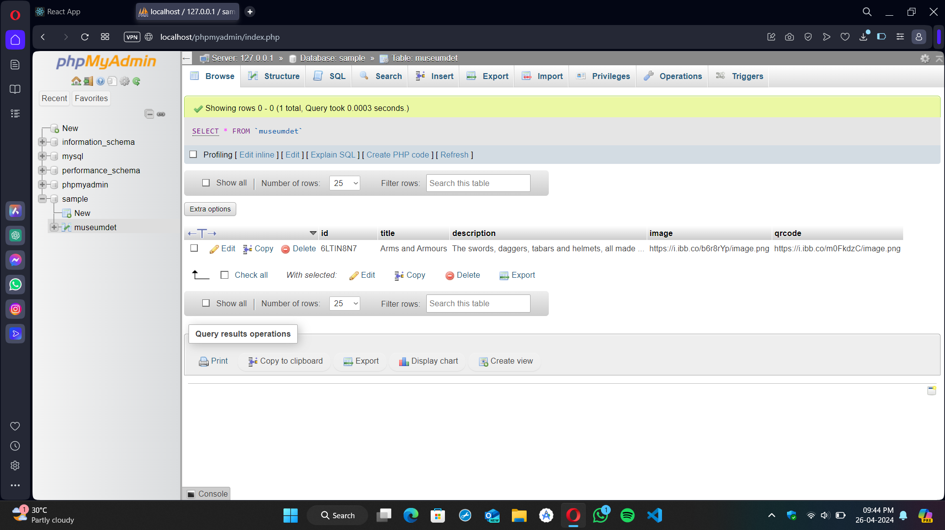

**Fig A2. 7 . Storing data in database**

**REFERENCES**

[1] Deepak Kumar Verma, Jitendra K Srivastava, Utkarsh Gupta, Divyansh Srivatsava, “QR Code Generator : A Security Perspective”, International Journal of Advanced Research in Computer and Communication Engineering, 2022.

[2] Rohit Sahay, Mayur Waghela, Abhishek Mulgaonkar, Vansh Tiwari, “QR Code Generator using Python”, International Journal of Advanced Research in Computer and Communication Engineering, 2022.

[3] Sunil Kunaragi, Suryakanth. Halburgi, U.A. Kaladagi, “Effective use of QR Code technology for library and information services”, Journal of Emerging Technologies and Innovative Research, 2021.

[4] Siyang Liu, Jian Guo, “Smart Museum and Visitor Satisfaction”, Journal of Autonomous Intelligence, 2023.

[5] Aman Sharma, Vibhor Sharma, “Language Translation using Machine Learning”, International Research Journal of Modernization in Engineering Technology and Science, 2021.

[6] Lakshmi V. Reballiwar, Sakshi B. Yergude, Vaidyavi M. Urade, Sayli R. Birewar, Prof. Bhagyashree Karmarkar, “Language Translation using Machine Learning”, International Journal of Advanced Research in Science, Communication and Technology, 2023.

[7] Bala Harshithaa B, “Language Translator App”, International Research Journal of Engineering and Technology, 2022.